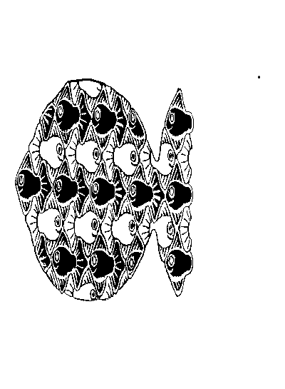
St. Andrew’s Church of England VC Primary School
Mill Race
Stanstead Abbotts
Nr. Ware
Hertfordshire
SG12 8BZ

Headteacher: Mrs Helen Gillingham
BA (Hons) PGCE MA NPQH

Telephone: 01920-870097

Web: www.standrews323.herts.sch.uk
Email: admin@standrews323.herts.sch.uk

Dear Parent

Re: Right Start Breakfast Club

As a matter of course, all the medical information that the school holds for each child is used by the Right Start Breakfast Club. However, as the club runs at a time before the School Office is open each morning, the information is not always easily available to the Breakfast Club staff. Therefore, we would be very grateful if you would confirm any allergies or food intolerances that your child has, by completing the attached slip. This information can be retained by Breakfast Club staff in order to ensure smooth running every morning.

If, as a result of an allergy or food intolerance, you would prefer to provide Breakfast Club with any specific provisions for your child, please use the attached slip to confirm this.

Thank you for your support of our Right Start Breakfast Club.

Yours sincerely

Mrs H. Gillingham
Headteacher

__________________________________________________________________________________

Right Start Breakfast Club Medical Information

Child’s name___________________________________________ Year____________

My child has the following medical condition __________________________________________which is relevant to the club.

My child has the following allergy/food intolerance _________________________________________ which is relevant to the club.

Due to my child’s allergy/ food intolerance, I wish to provide the following provisions for my child at

Breakfast Club _____________________________________________________________________

Signed______________________________________ Dated__________________________

