St. Andrew’s Church of England VC Primary School
Mill Race
Stanstead Abbotts
Nr. Ware
Hertfordshire
SG12 8BZ

Headteacher: Mr Michael Speed

Telephone: 01920-870097

Web: www.standrews323.herts.sch.uk
Email: admin@standrews323.herts.sch.uk
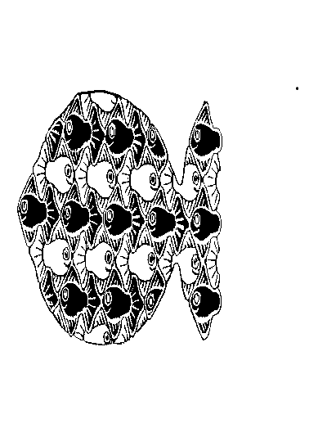

Toasties - Nursery Breakfast Club – admission form

Child’s name: ______________________________________

Date of birth: _______________________________________

Days required each week:

Monday Tuesday Wednesday Thursday Friday

Medical
As a matter of course, all the medical information that the school holds for each child is used by the Nursery Breakfast Club. However, as the club runs at a time before the School Office is open, the information is not always easily available to Breakfast Club staff. Therefore, we would be very grateful if you would confirm any allergies or food intolerances your child has, by completing the below: This information will be retained by Breakfast Club staff in order to ensure smooth running every morning.

My child has the following medical condition _______________________________________________________
(which is relevant to the club).

My child has the following allergy/food intolerance __________________________________________________
(which is relevant to the club).

Special Provision
If, as a result of an allergy or food intolerance, you would prefer to provide Breakfast Club with any specific provisions for your child, please provide details below.

Due to my child’s allergy/food intolerance, I wish to provide the following provisions for my child at Nursery Breakfast Club:

____________________________________________________________________________________________

Emergency contact details
Between 7.15am and 8.45am the best number to call is: ______________________________________________

Any additional relevant information

____________________________________________________________________________________________

____________________________________________________________________________________

O: Toasties: Nursery Breakfast Club: Admission form

