St. Andrew’s Church of England VC Primary School
Mill Race
Stanstead Abbotts
Nr. Ware
Hertfordshire
SG12 8BZ

Headteacher: Mrs Helen Gillingham
BA (Hons) PGCE MA NPQH

Telephone: 01920-870097

Web: www.standrews323.herts.sch.uk
Email: admin@standrews323.herts.sch.uk
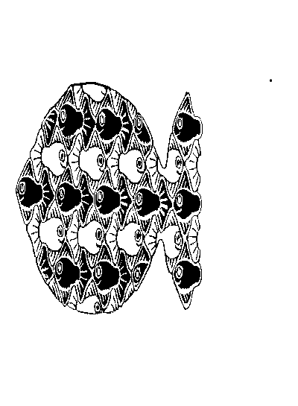

Nursery Breakfast Club – admission form

Child’s name: ______________________________________________________

Date of birth: _______________________________________________________

Days required each week:

Monday Tuesday Wednesday Thursday Friday

Medical
As a matter of course, all the medical information that the school holds for each child is used by the Nursery Breakfast Club. However, as the club runs at a time before the School Office is open each morning, the information is not always easily available to the Breakfast Club staff. Therefore, we would be very grateful if you would confirm any allergies or food intolerances that your child has, by completing the attached slip. This information can be retained by Breakfast Club staff in order to ensure smooth running every morning.

If, as a result of an allergy or food intolerance, you would prefer to provide Breakfast Club with any specific provisions for your child, please use the form below to confirm this.

My child has the following medical condition ____________________________________________________which is relevant to the club.

My child has the following allergy/food intolerance ______________________________________________ which is relevant to the club.

Due to my child’s allergy/food intolerance, I wish to provide the following provisions for my child at
Breakfast Club:

___________________________________________________________________________________________

Emergency contact details
Between 7.30am and 8.45am the best number to call is: ______________________________________________

Any additional relevant information

___________________________________________________________________________________________

____________________________________________________________________________________

